**DISEASE DETECTION AND DIAGNOSIS ON PLANT LEAF USING SVM CLASSIFIER**

1. Marvel Jacob,

Electronics and communication Department, Karunya Institute of Technology and Sciences, [marveljacob@gmail.com](mailto:marveljacob@gmail.com)

2. Job C Joy,

Electronics and communication Department, Karunya Institute of Technology and Sciences, [jobcjoy@karunya.edu.in](mailto:jobcjoy@karunya.edu.in)

3. Jugal Jose,

Electronics and communication Department, Karunya Institute of Technology and Sciences, [jugaljose@karunya.edu.in](mailto:jugaljose@karunya.edu.in)

**ABSTRACT**

This paper is to approach the agricultural needs of plants, trees and crops and the society. The major portion of our diet is from the cultivation of agricultural produce. Diseases effecting the plants reduced the overall functionality of the plant. The quality, quantity and the productivity will decrease due to these pathogens. The goal here is to quickly detect the abnormality in the plant from the leaves based on the colour, shape, texture. All these parameters are calculated in the form of values. This is needed for getting a better analysis on the leaf pattern and texture. The need of such a paper is quickly exterminate the disease after the detection so that none of the quality and yield gets affected. This improves the growth of plants and allows farmers to take the necessary steps to fend of the diseases and later on the precautions required. The various processes are done with the help of MATLAB with its inbuilt image processing tools. Identification of disease follows the steps like loading the image, contrast enhancement, converting RGB to HSI, extracting of features and SVM.

**Key words:** Plant leaf, disease detection, SVM, detection accuracy

**INTRODUCTION**

Agriculture is an area that many people depend on due to the reasons of it providing us the necessary essentials for survival. Since the plants are prone to get infected by diseases it a crucial role in detecting these diseases in plants in an agricultural field. If

the proper steps are not taken then the chances of lower yields are possible along with lesser quality and productivity which is a major setback in today’s environment as there is constant need of food. For instance, a disease named little leaf disease is a hazardous disease found in pine trees in United States.

Since the there are a wide variety of plants, manually finding diseases for each plant would be an enormous task so an automated system for detection is used. In olden days identification is done manually

by the experienced people but due to the so many environmental changes the prediction is becoming tough. So, we can use image processing techniques for identification of plant disease. Generally, we can observe the symptoms of

disease on leaf’s, stems, flowers etc. so here we use leafs for identification of disease affected plants.

**LITERATURE SURVEY**

Presently we have collected the pictures of plants such as banana leaf and pepper leaf. These pictures are then opened in matlab for processing. The image is converted to grayscale, then filtered by using the guassian filter. The filter produces a blurred image so it is then smoothened and gabon filter is applied. The resultant picture is the taking the colour of the pictures and highlighting the dark areas using the gabon filter. This method allows us to figure out the infected areas on the leaf. The images are segmented depending on the images and the feature extraction is carried out. The feature extraction is done in RGB, HSV, YIQ and Dithered Images. The feature extraction

from RGB image is added in the suggested system. A new automatic method for disease symptom segmentation in digital photographs of plant leaves. The diseases of different plant species has mentioned. Classification is done for

few of the disease names in this system. Classification is done on the basis of using an SVM classifier and it is an efficient and better result producing classifier. An identification of variety of leaf diseases using various data mining techniques is the potential research

area. The diseases of different plant species has mentioned. Classification is done for few of the disease names in

this system. The concept SVM for classification is used in this system.

**Proposed work**

**Image Acquisition:** First we need to select the plant which is affected by the disease and then collect the leaf of the plant and take a snapshot shot of the leaf and load the leaf image into the system.

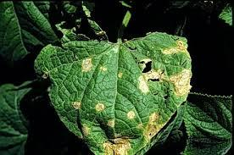

**Figure 1: Input image**

**Segmentation:** It means representation of the image in more meaningful and easy to analyse way. In segmentation a digital image is partitioned into multiple segments can defined as super-pixels.

**Feature extraction:** With the help of MATLAB certain filtering option and image processing steps, extraction of features like colour, shape and texture is done.

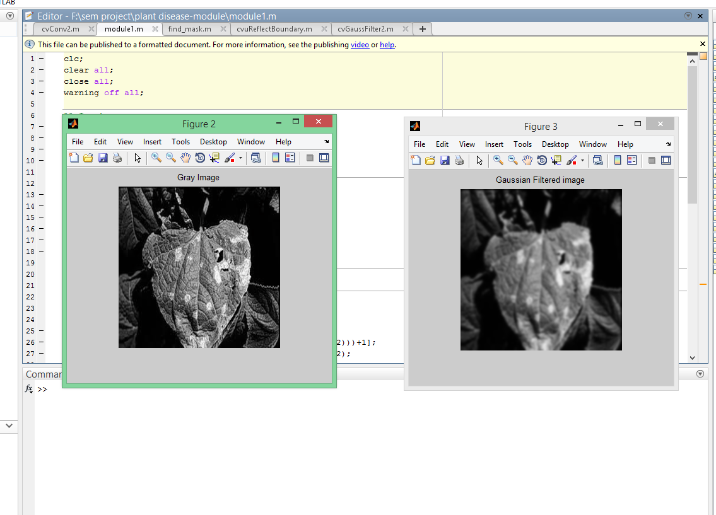

**Figure 2 : Image processing**

**Classification of plant disease:** Support Vector Machine (SVM) is a statistical learning-based solver. Statistical is a mathematics of uncertainty.it aims at gaining knowledge, making decisions from a set of data, which helps in high precision of identification of the disease.

**Jj** 



**Result**

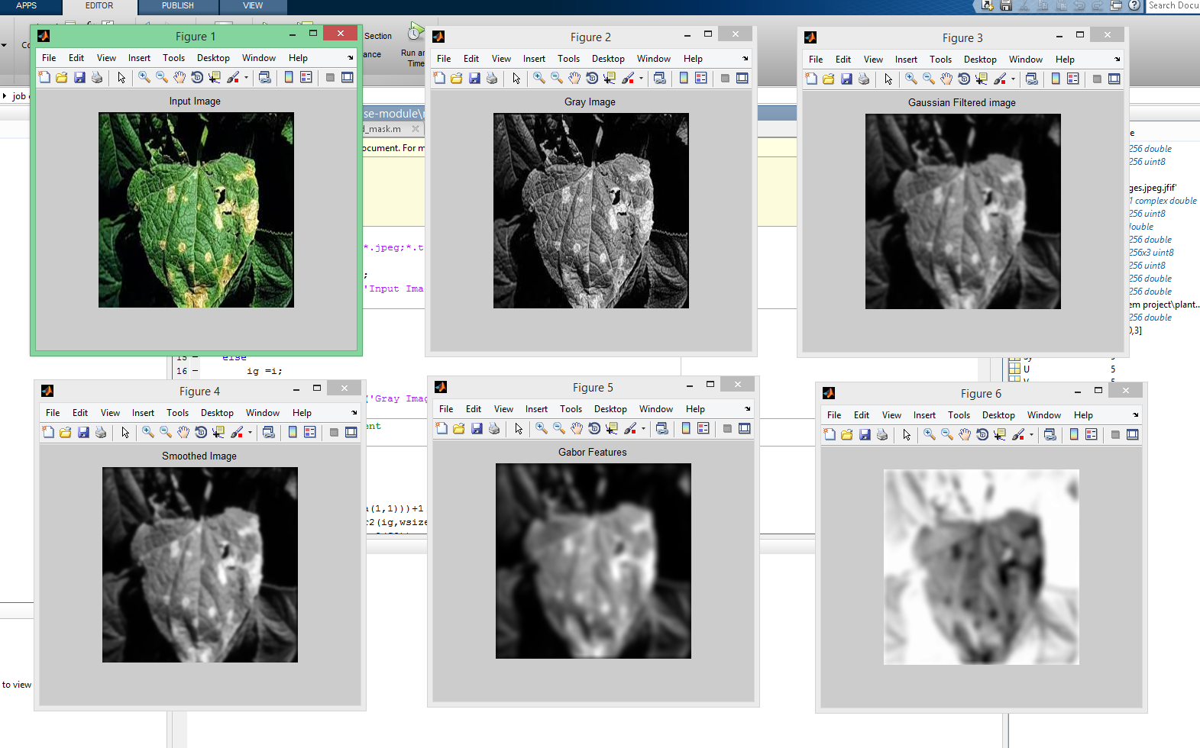

**Figure 3: Detection of disease region**

**Reference**

* Ghaiwat Savita N, Arora Parul. Detection and classification of plant leaf diseases using image processing techniques: are view. Int J Recent Adv Eng Technol 2014;2(3):2347–812. ISSN(Online).
* Dhaygude Sanjay B, Kumbhar Nitin P. Agricultural plant leaf disease detection using image processing. Int J Adv Res ElectrElectron Instrum Eng 2013;2(1).
* Mrunalini R Badnakhe, Deshmukh Prashant R. An applicationof K-means clustering and artificial intelligence in pattern recognition for crop diseases. Int Conf Adv Inf Technol2011;20. 2011 IPCSIT.
* Arivazhagan S, Newlin Shebiah R, Ananthi S, Vishnu Varthini S. Detection of unhealthy region of plant leaves and classification of plant leaf diseases using texture features. Agric Eng Int CIGR 2013;15(1):211–7.